Java Web Application Deployment Process

Followings processes are required for development of Java web application.

1. Installation of Tools (Java, Tomcat, PostgreSQL)
2. Creation of WAR File
3. WAR File Hosting
4. Other Settings
5. Database Backup and Restore
6. Installation of Tools (Java, Tomcat, PostgreSQL)

For installing all above tools download latest version of all from respective websites. It will download exe file for installation after that do following steps.

**JAVA Installation:**

**Step 1: Installation**

* Double click on java executable file which you have downloaded.
* The installation process is started .Windows security will ask you whether allow or not to run software. Click yes if asked.
* Click on Install button to accept license terms and start installation.
* Now just do next > next > Finish.

**Step 2: Set Java path in system Envirnment variable**

* + - Right Click on My Computer, Computer or This PC and Select properties.
    - In the left side, there is link Advanced System Settings. Click on it.
    - Go to Advanced tab and click on environment variables.
    - In System variable column click on New.
    - In the variable name write JAVA_HOME and in the variable value write java installation path it is in your program file location as C:\ProgrmeFiles\JAVA\jdk1.8.0 and click on ok to save.
    - Now find Path in variable name and select it. Click on edit.
    - Add %JAVA_HOME%\bin at the end. You must put semicolon (;) at the end of previous value before adding new value. Then click ok to save.

**Tomcat Installation:**

* Double click on executable file which you have downloaded. The installation process is started. Click on Next button.
* Before you can start the install, you must agree to the Apache License Agreement for the [Tomcat](https://www.liquidweb.com/kb/how-to-install-oracle-java-8-in-ubuntu-16-04/) 9 service.
* Click on “Select the type of install” dropdown list and choose the “[Full](https://www.liquidweb.com/kb/how-to-install-oracle-java-8-on-ubuntu-14-04-lts/)” install option and then click Next.
* Configure your tomcat settings.
* Next, you will choose the location where you want to install the [Tomcat](https://www.liquidweb.com/kb/how-to-install-oracle-java-8-on-ubuntu-12-04-lts/) 9 service. Click Next.
* Select Java or JRE Path and click Next.
* Once installation complete finish process.

**PostgreSQL Installation:**

* Double click on executable file which you have downloaded. The installation process is started. Click on Next button.
* Specify installation folder, choose your own or keep the default folder suggested by PostgreSQL installer and click the Next button.
* Select components to install and click the Next button.
* Select the database directory to store the data. Just leave it by default or choose your own and click the Next button.
* Enter the password for the database super user (postgres).
* Enter the port for PostgreSQL. Make sure that no other applications are using this port. Leave it as default if you are unsure.
* Choose the default locale used by the database and click the Next button.
* Ready to install PostgreSQL; Click the **Next** button to start installing. The installation may take a few minutes to complete. Click the **Finish** button to complete the PostgreSQL installation.

1. Creation of WAR(Web Archive File)

For creation of WAR file from eclipse you need to do following steps. After that it will generate War file to your desire location.

**Step 1: In the Eclipse Project Explorer; Right click on a project name and select Export>War File from the context menu.**

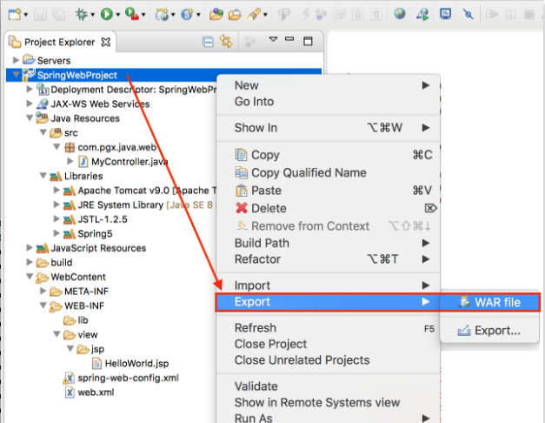

**Step 2: The WAR Export dialogue appears, we have to specify two required information**

* Specify the Web project you want to export (this field is primed if you used the pop-up menu to open the wizard).
* Specify path of the WAR file to be exported. The file must be end with”.war” extension.

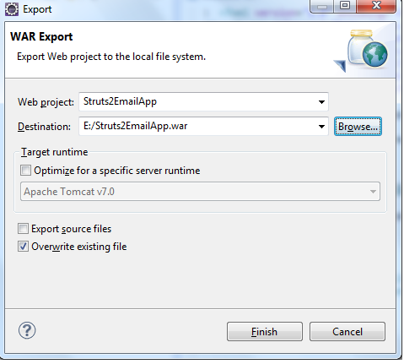

**Click Finish button it will generate your desired WAR file.**

1. WAR File Hosting

There are two ways for hosting war file on tomcat server. For doing this you need to follow next mention steps.

**Putting WAR File installed Tomcat Folder:**

For hosting purpose we can directly put WAR file into system installed tomcat webapps folder after doing this you need to do stop and start tomcat server.

**By Using Tomcat Application Manager**

**Step 1: Start your tomcat and logging into your tomcat application manager.**

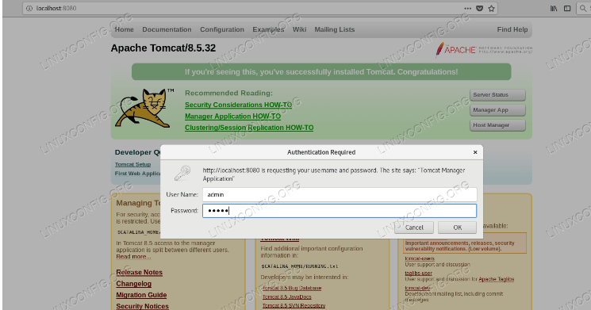

**Step 2: Browsing the location of WAR in manger application.**

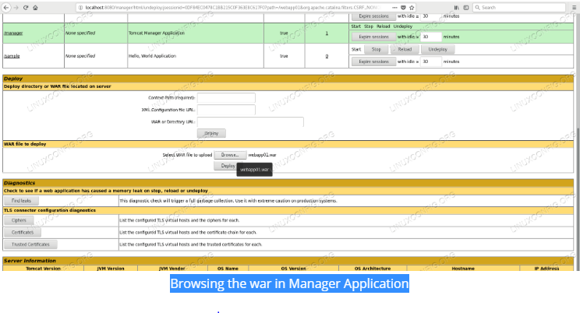

**Step 3: After submitting with Deploy button manager application will present main page again where hosted application will listed within deployed applications.**

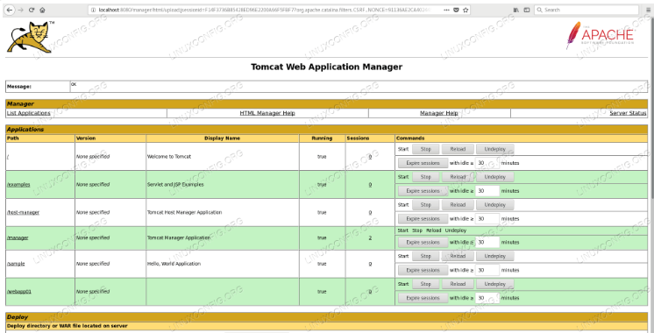

1. Other Settings

There are two setting are required for this application deployment process they are as follows.

**Database Configuration:**

Need to configure your configuration details in application-servlet configuration file as per your requirement before creation of WAR file you need to change following things.

* Database Location (IP Address of database installed machine, Local host IP).
* Database User Name (For pointing new database user name).
* Database password (For pointing new database password).
* Database Name which you are considering.

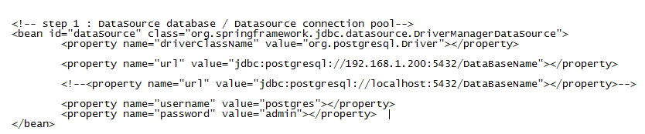

**Increase Heap Memory of Tomcat Server:**

Need to configure this setting for heap size error during large size file uploading in application. For setting this need to follow mention steps.

**Step 1:** Go to **Start > All Programs > Apache Tomcat x.x > Configure Tomcat**.

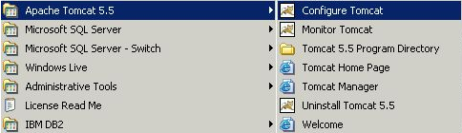

**Step 2: Go to the Java tab and specify a maximum memory pool as per requirement.**

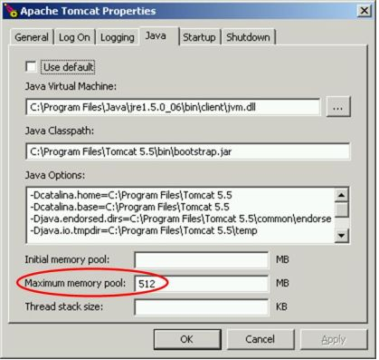

**Save the changes and startup or restart tomcat.**

1. Database Backup and Restore

**Database Backup:**

Using the pg_dump utility, pgAdmin provides an easy way to create a backup in a plain-text or archived format. You can backup a single table, a schema, or a complete database.

**Step 1: Select the name of the backup source in the pgAdmin tree control, right click to open the context menu, and select Backup… to open the Backup dialog.**

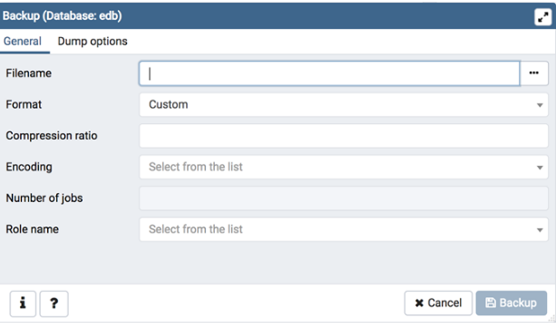

**Use the fields in the General tab to specify parameters for the backup:**

* Enter the name of the backup file with brows location in the Filename field.
* Select file format for generating back file (Custom, Tar, Plain, and Directory).
* Use the Compression Ratio field to select a compression level for the backup.
* Use the *Encoding* drop-down list box to select the character encoding method that should be used for the archive.
* Use the Number of Jobs field (when applicable) to specify the number of tables that will be dumped simultaneously in a parallel backup.
* Use the dropdown list box next to Role name to specify the role that owns the backup.

**Step 2: Click the Dump options tab to continue. Use the box fields in the Dump options tab to provide options for pg_dump.**

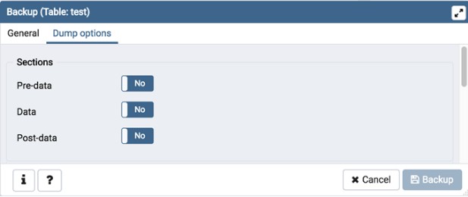

**Move switches in the Sections field box to select a portion of the object that will be backed up.**

* Move the switch next to Pre-data to the Yes position to include all data definition items not included in the data or post-data item lists.
* Move the switch next to Data to the Yes position to backup actual table data, large-object contents, and sequence values.
* Move the switch next to Post-data to the Yes position to include definitions of indexes, triggers, rules, and constraints other than validated check constraints.

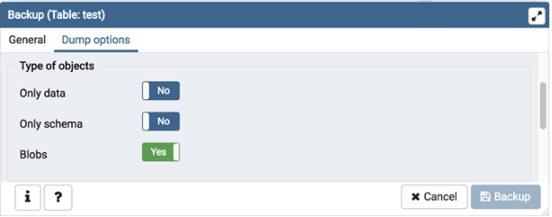

**Move switches in the Type of objects field box to specify details about the type of objects that will be backed up.**

* Move the switch next to only data to the Yes position to limit the back up to data.
* Move the switch next to only schema to limit the back up to schema-level database objects.
* Move the switch next to Blobs to the No position to exclude large objects in the backup.

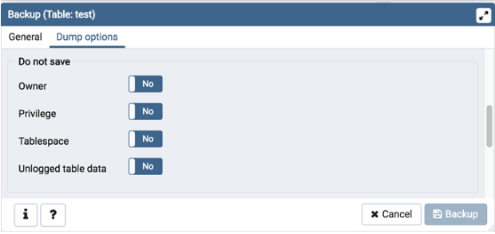

**Move switches in the Do not save field box to select the objects that will not be included in the backup.**

* Move the switch next to Owner to the Yes position to exclude commands that set object ownership.
* Move the switch next to Privilege to the Yes position to exclude commands that create access privileges.
* Move the switch next to Table space to the Yes position to exclude table spaces.
* Move the switch next to unlogged table data to the Yes position to exclude the contents of unlogged tables.

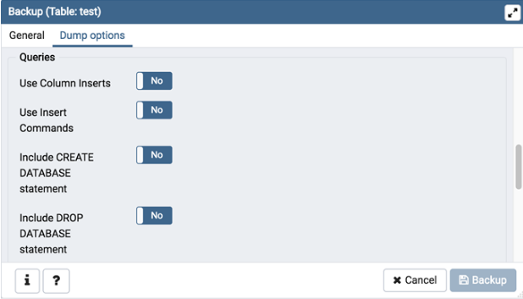

**Move switches in the Queries field box to specify the type of statements that should be included in the backup.**

* Move the switch next to Use Column Inserts to the Yes position to dump the data in the form of INSERT statements and include explicit column names.
* Move the switch next to Use Insert commands to the Yes position to dump the data in the form of INSERT statements rather than using a COPY command.
* Move the switch next to Include CREATE DATABASE statement to the Yes position to include a command in the backup that creates a new database when restoring the backup.
* Move the switch next to Include DROP DATABASE statement to the Yes position to include a command in the backup that will drop any existing database object with the same name before recreating the object during a backup.

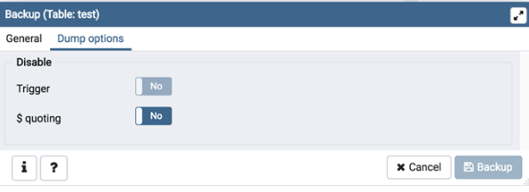

**Move switches in the Disable field box to specify the type of statements that should be excluded from the backup.**

* Move the switch next to Trigger (active when creating a data-only backup) to the Yes position to include commands that will disable triggers on the target table while the data is being loaded.
* Move the switch next to $ quoting to the Yes position to enable dollar quoting within function bodies; if disabled, the function body will be quoted using SQL standard string syntax.

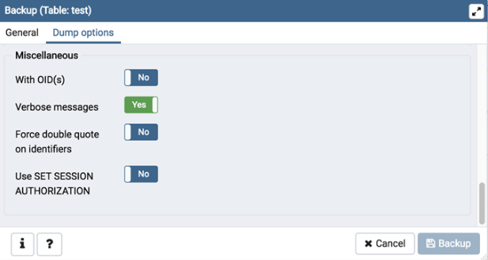

**Move switches in the Miscellaneous field box to specify miscellaneous backup options.**

* Move the switch next to With OIDs to the Yes position to include object identifiers as part of the table data for each table.
* Move the switch next to verbose messages to the No position to instruct pg_dump to exclude verbose messages.
* Move the switch next to Force double quotes on identifiers to the Yes position to force the quoting of all identifiers.
* Move the switch next to Use SET SESSION AUTHORIZATION to the Yes position to include a statement that will use a SET SESSION AUTHORIZATION command to determine object ownership (instead of an ALTER OWNER command).

**Step 3: Click the Backup button to build and execute a command that builds a backup based on your selections on the Backup dialog.**

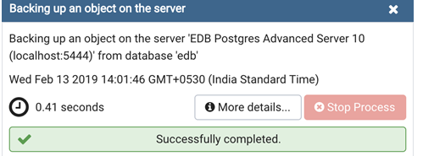

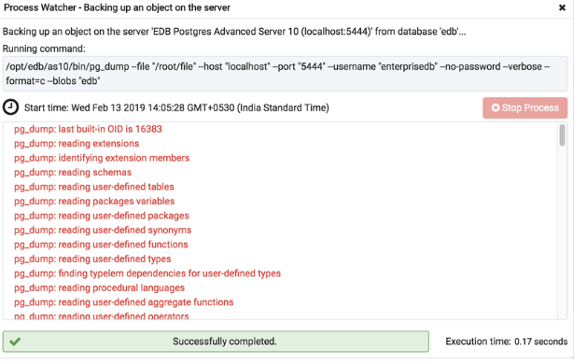

**Database Restore:**

The Restore dialog provides an easy way to use a Custom, tar, or Directory format backup taken with the pgAdmin Backup dialog to recreate a database or database object.

**Step 1: to restore, on the pgAdmin, create a empty database**

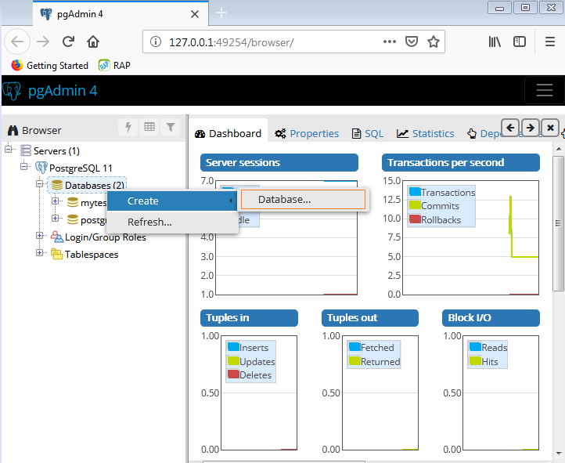

**Step 2: Select the name of the restore source in the pgAdmin tree control, right click to open the context menu, and select Restore… to open the Restore dialog.**

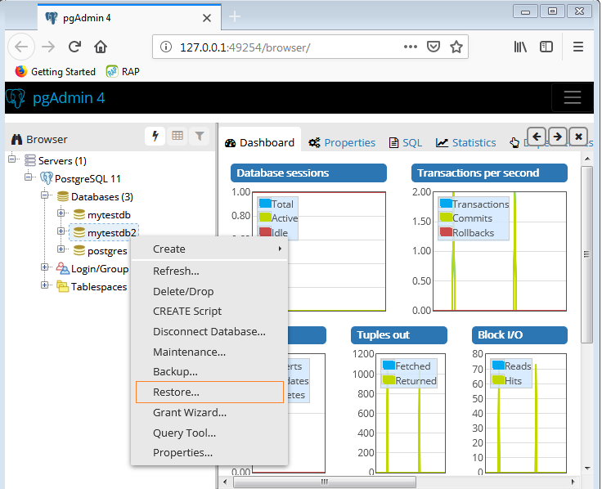

**Step 3: Use the Restore function to restore this database from the file which you have backed up.**

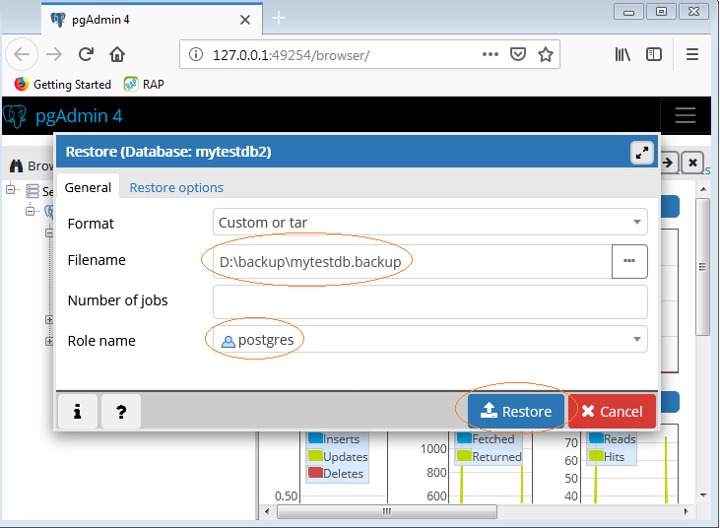

**In the restore options you need to select restore option as per your requirement. After Click on Restore button process will start and gives successful message.**

